PRACTICAL 1
QUESTION-: WRITE A PROGRAM TO CREATE A DATAFRAME HAVE E-COMMERCE DATA AND PERFORM SELECTION OF ROW/COLUMN USING LOC() AND ILOC().
SOURCE CODE :
import pandas as pd

print("Implemented by Chandan Pandey")

# Practical 1
data = {
'Item_Name': ['Shampoo', 'Laptop', 'Notebook', 'T-shirt', 'Washing Machine', 'Headphones'],
'Order_Id': ['X101', 'Y202', 'Z303', 'A404', 'B505', 'C606'],
'Customer_Id': [111, 112, 113, 114, 115, 116],
'Price': [500, 60000, 50, 800, 25000, 3000],
'Quantity': [3, 1, 5, 2, 1, 4],
'Discount': [5, 2000, 2, 50, 3000, 500],
'Total_Price': [1425, 58000, 240, 1550, 22000, 11000]
}

edata = pd.DataFrame(data)
print("Full DataFrame:")
print(edata)
print("\nSelected rows and columns using iloc:")
print(edata.iloc[2:5, 1:4])
print("\nSelected columns using loc:")
print(edata.loc[0:4, ['Item_Name', 'Quantity', 'Discount', 'Total_Price']])

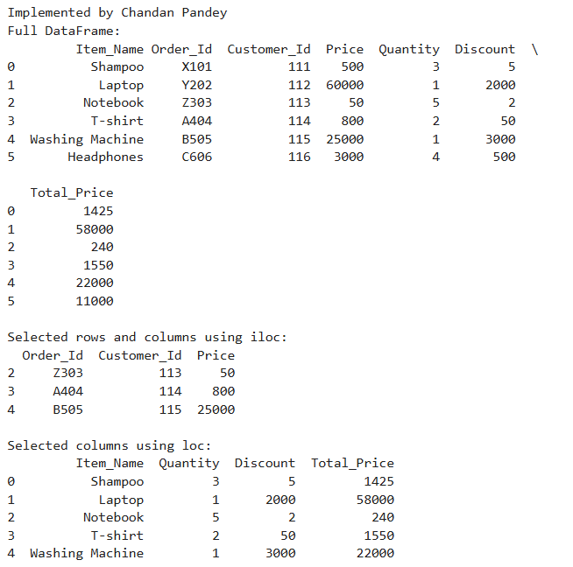
OUTPUT :

PRACTICAL 2
QUESTION-: CREATE A SERIES OBJECT S5 CONTAINING NUMBERS. WRITE A PROGRAM TO STORE THE SQUARE OF THE SERIES VALUES IN OBJECT S6. DISPLAY S6’S VALUES WHICH ARE >15.
SOURCE CODE :
import pandas as pd

print("Implemented by Chandan Pandey")
S5 = pd.Series([1, 2, 3, 4, 5, 6, 7, 8, 9, 10])
S6 = S5 ** 2
filtered_S6 = S6[S6 > 15]
print("\nOriginal Series (S5):")
print(S5)
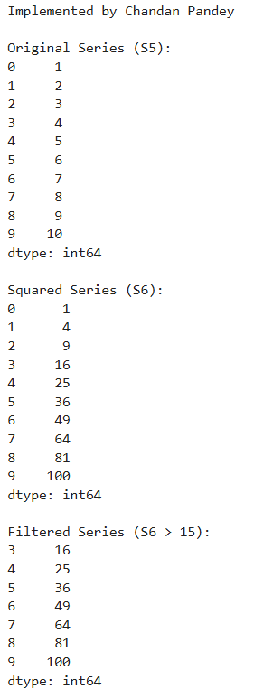
print("\nSquared Series (S6):")
print(S6)
print("\nFiltered Series (S6 > 15):")
print(filtered_S6)

OUTPUT :

PRACTICAL 3
QUESTION-: WRITE A PROGRAM TO CREAT A OBJECT (TEMP) STORAGING THE TEMPERATURE OF 7 DAYS OF THE WEEK CREATE A SERIES AND PRINT SUCH THAT IT DISPLAYS THE WEEK NAEM ALONG WITH THE TEMPERATURE.
SOURCE CODE :
import pandas as pd

print("Implemented by Chandan Pandey")
temperatures = {
'Monday': 25, 'Tuesday': 28, 'Wednesday': 22, 'Thursday': 30,
'Friday': 27, 'Saturday': 26, 'Sunday': 24
}
temp = pd.Series(temperatures)
print("\nTemperature Series:")
print(temp)
OUTPUT :
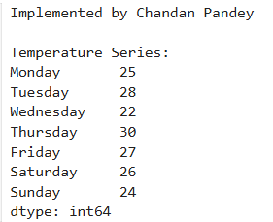

PRACTICAL 4
QUESTION-: CREATE A DATA FRAME AID THAT STORE AID (TOYS,BOOK,UNIFORM,SHOES) BY NGO'S FOR DIFFERENT STATES. WRITE A PROGRAM TO DISPLAY THE AID FOR:
1. BOOK AND UNIFORM ONLY 2. SHOES ONLY
SOURCE CODE :
import pandas as pd

print("Implemented by Chandan Pandey")
data = {
'States': ['U.P', 'Bihar', 'Chennai', 'Mumbai', 'Delhi', 'Uttarakhand'],
'Toys': [400, 500, 600, 700, 800, 900],
'Books': [150, 300, 450, 600, 750, 900],
'Uniform': [500, 600, 700, 800, 900, 1000],
'Shoes': [100, 200, 300, 400, 500, 600]
}
Aid = pd.DataFrame(data)
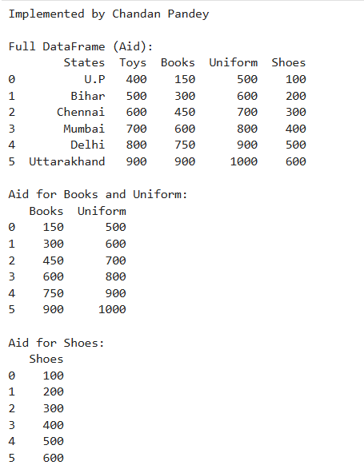
print("\nFull DataFrame (Aid):")
print(Aid)
print("\nAid for Books and Uniform:")
print(Aid.loc[:, ['Books', 'Uniform']])
print("\nAid for Shoes:")
print(Aid.loc[:, ['Shoes']])
OUTPUT :

PRACTICAL 5
QUESTION-: WAP TO CREATE 3 DIFFERET SERIES OBJECT FROM 3 COLUMN OF A DATAFRAME
SOURCE CODE :
import pandas as pd
print("Implemented By Chandan Pandey")
data = {
'A': [1, 2, 3, 4, 5],
'B': [10, 20, 30, 40, 50],
'C': [100, 200, 300, 400, 500]
}
df = pd.DataFrame(data)
series_A = df['A']
series_B = df['B']
series_C = df['C']

# Displaying the Series
print("Series A:\n", series_A, "\n")
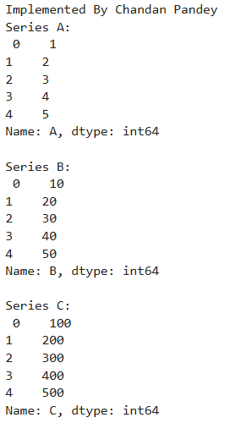
print("Series B:\n", series_B, "\n")
print("Series C:\n", series_C)
OUTPUT :

PRACTICAL 6
QUESTION-: WRITE A PROGRAM TO CREATE A DATA FRAME WITH SOME MISSING VALUES AND FILL ALL MISSING VALUES IN IT WITH ZEROES
SOURCE CODE:
import pandas as pd
import numpy as np
print("Implemented by Chandan Pandey")
data = {'A': [1, 2, np.nan, 4], 'B': [8, np.nan, 5, 4], 'C': [np.nan, 6, np.nan, 7]}
edata = pd.DataFrame(data)
print("\nOriginal DataFrame with Missing Values:")
print(edata)
edata_filled = edata.fillna(0)
print("\nDataFrame after Filling Missing Values:")
print(edata_filled)
OUTPUT :
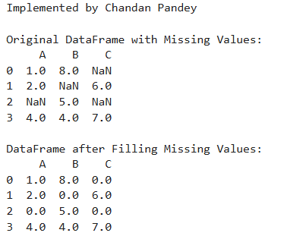

PRACTICAL 7
QUESTION-: WRITE A PROGRAM FOR TO SHOW COMBINING DATAFRAMES USING CONCAT(), JOIN(),MERGE() FUNCTIONS.
SOURCE CODE:
import pandas as pd
print("Implemented by Chandan Pandey")
df1 = pd.DataFrame({'A': ['A0', 'A1', 'A2', 'A3'], 'B': ['B0', 'B1', 'B2', 'B3'], 'C': ['C0', 'C1', 'C2', 'C3']})
df2 = pd.DataFrame({'X': ['A4', 'A5', 'A6', 'A7'], 'Y': ['B4', 'B5', 'B6', 'B7'], 'Z': ['C4', 'C5', 'C6', 'C7']})
df3 = pd.DataFrame({'D': ['D0', 'D1', 'D2', 'D3'], 'E': ['E0', 'E1', 'E2', 'E3'], 'F': ['F0', 'F1', 'F2', 'F3']})
Cdata = pd.concat([df1, df2], axis=0)
print("\nConcatenated DataFrame:")
print(Cdata)
df1.set_index('A', inplace=True)
df3.set_index('D', inplace=True)
joined = df1.join(df3, how='outer')
print("\nJoined DataFrame (Outer Join):")
print(joined)
df4 = pd.DataFrame({'key': ['K0', 'K1', 'K2', 'K3'], 'B': ['B0', 'B1', 'B2', 'B3'], 'C': ['C0', 'C1', 'C2', 'C3']})
df5 = pd.DataFrame({'key': ['K0', 'K1', 'K2', 'K3'], 'G': ['G0', 'G1', 'G2', 'G3'], 'H': ['H0', 'H1', 'H2', 'H3']})
merged = pd.merge(df4, df5, on='key')
print("\nMerged DataFrame (on='key'):")
print(merged)
OUTPUT :

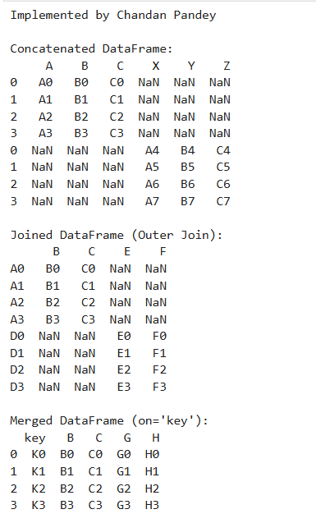

PRACTICAL 8
QUESTION-: MARKS IS A LIST THAT STORES MARKS OF A STUDENT IN 10 UNIT TEST. WRITE A PROGRAM TO PLOT LINE CHART FOR THE STUDENT’S PERFORMANCE IN THESE 10 TESTS.
SOURCE CODE:
import pandas as pd
import matplotlib.pyplot as plt
print("Implemented by Chandan Pandey")
marks = [75, 80, 78, 85, 90, 88, 76, 84, 89, 92]
tests = list(range(1, 11))
plt.figure(figsize=(10, 5))
plt.plot(tests, marks, marker='o', linestyle='-', color='b', label='Marks')
plt.title("Student's Performance in 10 Unit Tests")
plt.xlabel('Test Number')
plt.ylabel('Marks')
plt.xticks(tests)
plt.grid(True)
plt.legend()
plt.show()
OUTPUT :
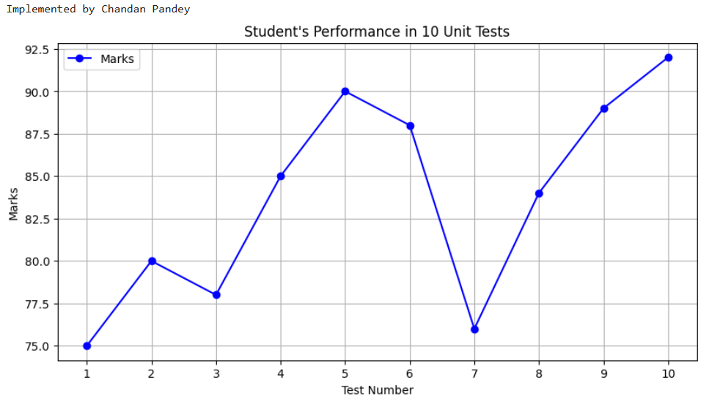
PRACTICAL 9
QUESTION-: WRITE A PROGRAM TO PLOT A HORIZONTAL BAR CHART FROM THE HEIGHT OF SOME STUDENTS.
SOURCE CODE:
import pandas as pd
import matplotlib.pyplot as plt
print("Implemented by Chandan Pandey")
students = ['Alice', 'Bob', 'Charlie', 'David', 'Eve']
heights = [150, 160, 170, 180, 190]
plt.figure(figsize=(10, 5))
plt.barh(students, heights, color='skyblue')
plt.title("Heights of Students")
plt.xlabel('Height (cm)')
plt.ylabel('Students')
plt.grid(True, axis='x')
plt.show()
OUTPUT :
